**Electrically Tunable Exchange Bias**

Peyton Murray1, Junwei Zhang2, Xixiang Zhang2, Kai Liu1,3*

*1Physics Department, University of California, Davis, CA 95616, USA*

*2King Abdullah University of Science & Technology, Thuwal 23955-6900, Kingdom of Saudi Arabia*

*3Physics Department, Georgetown University, Washington, DC 20057, USA*

*Corresponding author: Kai.Liu@georgetown.edu

**Abstract**

Electrically induced ionic motion offers a new way to realize voltage-controlled magnetism, opening the door to a new generation of logic, sensor, and data storage technologies. Here, we demonstrate a two-step approach towards magnetoionic control of exchange bias. First, a Gd capping layer is deposited onto thin film antiferromagnetic Ni0.5Co0.5O, initiating a solid-state redox reaction which reduces the oxide to ferromagnetic NiCo in a thin interfacial region. Upon field cooling, the hysteresis loop becomes exchange biased, demonstrating interfacial coupling between the NiCo and the remaining oxide. Second, an electric field is applied perpendicular to the interface, driving O2- ions toward the Gd layer. Subsequent magnetometry reveals an increase in the exchange bias by ~15%, while electron microscopy directly images ion-migration-induced chemical segregation and microstructural disorder. While these effects do not appear to be electrically reversible in this system, thermal cycling resets the exchange bias back to its field-cooled value. These results highlight the viability of this approach for controlling interfacial magnetic properties, and suggest new routes toward systems with improved magnetoionic performance.

Methods aiming to control magnetism using electric fields have attracted significant interest in recent years with the promise of enabling a new generation of nonvolatile, low-dissipation electronics. While prevailing semiconductor-based logic and memory technologies rely on electric currents and are therefore subject to energy losses due to joule heating, electric field-based approaches in principle have no such limitation. Recent research has shown ionic migration to be a powerful tool for modifying the magnetic properties of metallic and oxide ferromagnets. For example, several experiments have demonstrated reversible control of interfacial anisotropy in Pt/GdOx/Co trilayers1–4. In these trilayer systems, charged oxygen ions, which exist in the -2 valence state in the GdOx layer, are mobile and move under an externally applied electric field – even at room temperature. A correctly oriented electric field can therefore drive these ions towards the Co interface to initiate an oxidation reaction. The resulting changes in chemistry as well as Co-O coordination can modify the magnetic moment2,4 or interface anisotropy1, leading to significant improvements in magneto-electric efficiency. Remarkably these effects are reported to be at least partially reversible, particularly at elevated temperatures, with reverse bias acting to reduce the Co interface back to a metallic state. As an alternative to electric-field-based approaches, we recently demonstrated control of oxygen-ion distributions using chemically-induced ionic motion5–7; this approach involves deposition of a thin capping layer of Gd onto an oxide thin film. Due to the high oxygen affinity of Gd and the high ionic mobility of GdOx, a solid-state redox reaction occurs at the metal/oxide interface at room temperature, leaching oxygen from the oxide, with the amount of oxygen removed controlled by the Gd capping layer thickness5–7. In oxides with high ionic mobility, ionic migration effects can extend well beyond the interface, extending the utility of this technique to the quasi-bulk regime – far deeper than the effective ranges thus far demonstrated by electric-field-based techniques. This chemically-induced ionic migration mechanism has been demonstrated as an effective way to modify structure, stoichiometry, transport properties, and magnetism in a variety of functional oxides5–7.

Here, we present a new method for electrically tuning exchange bias in a thin film Ni0.5Co0.5O/Gd bilayer system. Our approach combines the extremely strong ionic migration generated by the redox-based technique with electrical biasing to allow for on-demand modification of exchange bias. Since exchange bias is extremely sensitive to changes in interfacial chemistry and morphology8–11, the effect is a delicate probe of magnetoionic activity. In our approach, a thin metallic Gd capping layer is deposited onto antiferromagnetic (AF) Ni0.5Co0.5O (NiCoO); due to the extreme oxygen reactivity of metallic Gd, this capping layer strips oxygen away from the NiCoO, reducing the oxide near the interface to ferromagnetic (FM) NiCo alloy. Upon field cooling, the major hysteresis loop is exchange biased, demonstrating that the interfacial FM layer is magnetically coupled to pinned uncompensated moments in the remaining AF oxide. Upon application and removal of an electric field oriented perpendicular to the interface, an enhancement of the exchange bias by ~15% is observed. Electron microscopy images of the NiCoO/Gd interface show disruption to the microstructure as well as changes to the NiCo layer chemistry, both effects which are attributed to ionic motion. Although reverse biasing the interface has no effect on the magnetic reversal behavior, further thermal cycling resets the major loop back to the field cooled state, indicating that these magnetoionic effects may be at least partially reversible. Our results demonstrate the viability of this approach for tuning interfacial magnetism through ionic motion, and highlight a new pathway towards nonvolatile and energy efficient magnetic switching devices.

The layer structure of the samples studied was Si (substrate, naturally oxidized)/Ta (1 nm)/Pt (10 nm)/Al2O3 (170 nm)/Ni0.5Co0.5O (20 nm)/Gd (20 nm)/Pt (10 nm), with Pt layers functioning as electrodes for the application of an electric field and Al2O3 as a conduction barrier (Fig. 1). Films were fabricated at room temperature via sputtering and patterned using standard photolithographic processing and lift-off techniques to allow access to the bottom electrode after fabrication. Magnetometry measurements were carried out on two identically-prepared films (samples A and B) in the as-grown state, again after a field cooling, and once again after undergoing a voltage-conditioning procedure. Afterward, sample A was measured after a reverse-bias voltage-conditioning procedure, while sample B was measured after field-cooling a second time. Room temperature magnetometry of the as-grown states in both samples show a nonzero ferromagnetic moment (Fig. 2a), even though none of the constituent materials exhibit ferromagnetism at this temperature (Gd 12. Only NiCoO contains elements which are ferromagnetic at room temperature in their metallic form, indicating a partial reduction of NiCoO has occurred to form NiCo (Fig. 1 inset). Upon heating above the NiCoO Neél temperature (13,14 to 420 K and cooling back to room temperature in a 10 kOe magnetic field, the major loop becomes biased and the coercivity increases (Fig. 2a). Both of these effects are expected for an exchange biased system8–11, again suggesting the formation of a ferromagnetic NiCo layer adjacent to the antiferromagnetic NiCoO. The emergence of a magnetic moment is also consistent with our previous work on a NiCoO/GdFe system, where a magnetic signal originating from Ni and Co moments at the interface of the bilayer was directly observed via x-ray spectroscopy and polarized neutron reflectometry6.

In sample A, the effects of electric-field-induced ionic motion on the magnetic behavior of the interfacial NiCo layer were investigated by applying an electric field of 0.5 MV/cm in the direction from the Gd toward the NiCoO at room temperature for 12 hours. In this orientation, O2- ions in the NiCoO layer are expected to drift toward Gd. Magnetometry of the resulting voltage-conditioned sample shows both an enhancement in coercivity as well as bias (ΔHc = 16 Oe, ΔHb = –31 Oe) (Fig. 2b) as compared to the field cooled state, indicative of interfacial magnetoionic activity. Subsequent voltage conditioning under a reverse bias at room temperature had no significant effect on the hysteretic behavior of the interfacial layer, demonstrating a degree of irreversibility. Although room temperature reverse-biasing had no effect on the magnetic behavior, ionic diffusion is known to be enhanced at elevated temperatures15. To examine the thermal stability of the voltage-conditioned state, sample B was prepared similarly to sample A: field cooling gave rise to exchange bias (Fig. 3a), and voltage conditioning again resulted in an enhancement in the coercivity and bias (ΔHc = 9 Oe, ΔHb = –25 Oe). Finally, a second field cooling procedure was carried out from 420 K to room temperature in a 10 kOe field. Subsequent magnetometry shows the major loop returning from the voltage-conditioned state back to the original field cooled state (Fig. 3b).

To further understand the evolution of the interfacial ferromagnetic layer after field cooling and voltage conditioning, high resolution scanning transmission electron microscopy (STEM) was carried out on three additional samples prepared in the as-grown (AG), field cooled (FC), and field cooled+voltage conditioned (FCVC) states. Representative images of the NiCoO/Gd interface show each layer to be polycrystalline in the as grown state (Fig. 4a), with an abrupt boundary between the two materials. After field cooling only a few crystal planes are visible; as thermal treatment often improves crystallinity16, this amorphization is likely the result of ionic migration, enhanced by the elevated temperature reached during field cooling (Fig. 4b). After voltage conditioning the region near the interface remains largely amorphous and the interface becomes less abrupt (Fig. 4c). While NiCoO grains are visible in the AG and FC state, none are visible in the FCVC state. Since ionic diffusion is expected to be greater at grain boundaries15,17 as compared to diffusion through the bulk, the disruption of the NiCoO grains is likely a contributing factor to irreversibility of the voltage-conditioning effects under reverse bias. In addition to microscopy, elemental distributions were mapped across the NiCoO/Gd interface via electron energy loss spectroscopy (EELS) (Fig. 4d-f); in the field-cooled sample, the oxygen concentration goes to zero well before the interface, directly confirming the presence of the interfacial FM. Interestingly, a significant overlap in the Gd/NiCo distributions is present, indicating some interdiffusion has occurred. Additionally, clear segregation between Ni and Co atomic distributions occurs near the Gd interface, indicating that metal ions participate in ionic migration. This segregation can be explained by the generally lower enthalpies of formation of Gd-Ni compounds, which are energetically favored over Gd-Co alloys18,19. As the oxygen leaching process leaves behind metallic Ni and Co, Gd-Ni alloys preferentially form, causing the Co distribution to be pushed deeper into the remaining NiCoO. EELS analysis shows further segregation between the Ni and Co elemental distributions after voltage conditioning, further supporting ionic migration as the mechanism behind the observed chemical separation.

The magnetic behavior of the NiCoO/Gd system is the result of two separate ion migration mechanisms. The first mechanism occurs during deposition of the Gd layer, which results in a chemically-induced redox reaction that strips oxygen from the adjacent NiCoO, leaving behind the ferromagnetic layer of NiCo observed via magnetometry. The gadolinium oxidation process is energetic; taking the enthalpy of formation of NiO and CoO to be the same ((Ni, Co) + O $→$ ΔH = –2.5 eV), the reaction is exothermic, producing (3(Ni, Co)O + 2Gd $→$ 3(Ni, Co) + Gd2O3) ΔH = –11.4 eV of heat per molecule of Gd2O3 formed20. Thus, local heating may increase ionic mobility in the surrounding region, although the degree to which this feedback effect drives the redox reaction is difficult to quantify due to the inhomogeneity of the interface. While the magnetic moment observed in magnetometry corresponds to a layer thickness of only ~1.5 Å assuming equal Ni and Co concentration, the amorphous region formed near to the NiCoO/Gd interface is actually much wider due to the disruption of the nearby Gd and NiCoO by the redox reaction (**Fig. 2a**). The magnetization of this structurally disordered region is likely to be lower than expected for a binary alloy, owing to residual oxygen and differences in atomic coordination as compared to the crystalline phase. As this system is field cooled, the enhanced ionic mobility combined with the chemical potential gradient provided by the Gd interface induces further oxygen migration, disrupting an even larger region near the interface. The resulting amorphization of the interface is observed in the STEM image of the FC sample. After field cooling, the hysteresis loop is exchange biased by the coupling between the interfacial FM NiCo and the remaining AF NiCoO.

The second ionic migration mechanism, electric-field-induced motion, occurs as a result of voltage conditioning. During voltage conditioning, the interfacial NiCo becomes further enriched with Ni via the alloying-enthalpy mechanism discussed previously. As the ratio of Ni (*Ms* = 495 emu/cm3) to Co (*Ms* = 1400 emu/cm3) increases, the remaining interfacial FM layer has a reduced magnetization compared to the field-cooled state. According to Malozemoff’s random field model21, the observed exchange bias is inversely proportional to the saturation magnetization of the interfacial ferromagnet:

$$H_{b}=\frac{2z\sqrt{AK}}{π^{2}M_{s}t}$$

where *A* and *K* are the AF layer exchange stiffness and anisotropy, *Ms* and *t* are the FM layer saturation magnetization and thickness, and *z* is a number of order unity which depends on the shape of AF domains. As the interfacial FM magnetization decreases due to the ionic migration of Co, the bias increases accordingly. Additionally, the STEM images show that the electric-field-induced ionic motion disrupts the grain boundaries of the Gd and NiCoO; since ion mobility is expected to be highest here, disruption to these pathways renders the ionic distributions immobile and leads to the irreversibility under reverse bias. By contrast, a second field cooling procedure resets the bias to its original value. Since bulk ionic diffusivity is enhanced at elevated temperature, grain boundaries play less of a role in ionic migration during thermal treatment, allowing the interface to recover to a pre-voltage-conditioned state.

In summary, the unusual magnetic behavior of the NiCoO/Gd system has been discussed. The formation of a ferromagnetic NiCo layer near the interface as a result of Gd-driven, redox-induced ionic migration has been established via magnetometry and electron microscopy. Field cooling behavior typical of exchange biased FM/AF systems was observed, with the interfacial NiCo coupling to the remaining oxide. Importantly, the exchange bias in this system can be enhanced by up to 15% under a voltage-conditioning procedure, an effect which can be qualitatively explained by chemical segregation and Ni enrichment of the interfacial FM layer. Finally, this effect was found to be reversible under thermal cycling but not under reverse biasing, due to ionic-migration-induced disruption of grain boundaries near the interface, which comprise the most effective ionic pathways. These results demonstrate a new magnetoionic approach for controlling exchange bias, with greater switching speed and larger changes to the bias likely possible under further material optimization and improved fabrication processes.

**References**

1. Bauer, U. *et al.* Magneto-ionic control of interfacial magnetism. *Nat. Mater.* **14,** 174–181 (2015).

2. Bi, C. *et al.* Reversible control of Co magnetism by voltage-induced oxidation. *Phys. Rev. Lett.* **113,** 267202 (2014).

3. Bauer, U., Emori, S. & Beach, G. S. D. Voltage-controlled domain wall traps in ferromagnetic nanowires. *Nat. Nanotechnol.* **8,** 411–416 (2013).

4. Gilbert, D. A. *et al.* Structural and magnetic depth profiles of magneto-ionic heterostructures beyond the interface limit. *Nat. Commun.* **7,** 12264 (2016).

5. Grutter, A. J. *et al.* Reversible control of magnetism in La0.67Sr0.33MnO3 through chemically-induced oxygen migration. *Appl. Phys. Lett.* **108,** 082405 (2016).

6. Gilbert, D. A. *et al.* Controllable positive exchange bias via redox-driven oxygen migration. *Nat. Commun.* **7,** 11050 (2016).

7. Gilbert, D. A. *et al.* Ionic tuning of cobaltites at the nanoscale. *Phys. Rev. Mater.* **2,** 104402 (2018).

8. Nogués, J. & Schuller, I. K. Exchange bias. *J. Magn. Magn. Mater.* **192,** 203–232 (1999).

9. Kiwi, M. Exchange bias theory. *J. Magn. Magn. Mater.* **234,** 584–595 (2001).

10. Ohldag, H. *et al.* Correlation between Exchange Bias and Pinned Interfacial Spins. *Phys. Rev. Lett.* **91,** 2–5 (2003).

11. Berkowitz, A. E. & Takano, K. Exchange anisotropy — a review. *J. Magn. Magn. Mater.* **200,** 552–570 (1999).

12. Kittel, C. *Introduction to Solid State Physics*. (John Wiley & Sons, Inc, 2005).

13. Ambrose, T., Liu, K. & Chien, C. L. Doubly exchange-biased NiCoO/NiFe/Cu/NiFe/NiCoO spin valves. *J. Appl. Phys.* **85,** 6124–6126 (1999).

14. Yang, D. Z. *et al.* Positive exchange biasing in GdFe/NiCoO bilayers with antiferromagnetic coupling. *Phys. Rev. B - Condens. Matter Mater. Phys.* **71,** 144417 (2005).

15. Balluffi, R. W., Allen, S. M. & Carter, W. C. *Kinetics of Materials*. (A. John Wiley & Sons, 2005).

16. Hotovy, I., Liday, J., Spiess, L., Sitter, H. & Vogrincic, P. Study of Annealed NiO Thin Films Sputtered on Unheated Substrate. *Japanese J. Appl. Physics, Part 2 Lett.* **42,** (2003).

17. Kim, Y. M. *et al.* Probing oxygen vacancy concentration and homogeneity in solid-oxide fuel-cell cathode materials on the subunit-cell level. *Nat. Mater.* **11,** 888–894 (2012).

18. Colinet, C., Pasturel, A. & Buschow, K. H. J. Study of the Enthalpies of Formation in the Gd-Ni System. *Metall. Trans. A* **17A,** (1986).

19. Colinet, C., Pasturel, A. & Buschow, K. H. J. Study of the enthalpies of formation in the Gd-(Fe, Co, Pd, Pt) systems. *Metall. Trans. A* **18,** 903–907 (1987).

20. Dean, J. A. *Lange’s Handbook of Chemistry*. (McGraw-Hill, 1999).

21. Malozemoff, A. P. Random-field model of exchange anisotropy at rough ferromagnetic- antiferromagnetic interfaces. *Phys. Rev. B* **35,** 3679–3682 (1987).

**Acknowledgements:** We thank Professor Yayoi Takamura from UC Davis for enlightening discussions.

**Funding:**

**Author contributions:** P. D. M. fabricated the samples, carried out magnetic measurements, and wrote the manuscript. J. Z. took TEM images. X. Z. and K. L supervised the experiments and advised the project. **Competing interests:** The authors declare no competing interests. **Data and materials availability:** Experimental data is available upon request.

**Figures**

**Figure 1.** Layer structure of the samples **(a)**, and close up showing interfacial NiCo which forms immediately upon Gd deposition (inset). Major loops of sample A in the as-grown (AG) and field cooled (FC) states **(b)**. Major loops of sample A after field cooling (FC), positive voltage conditioning (FC+VC), and after reverse bias voltage conditioning (FC-VC) **(c)**. Major loops of sample B in the as-grown (AG) and field cooled (FC) states **(d)**. Major loops of sample A after field cooling (FC), positive voltage conditioning (FCVC), and after a second field cooling procedure (FCVCFC) **(e)**.

**Figure 2.** STEM images of the Gd/NiCoO interface for the as-grown **(a)**, field cooled **(b)**, and voltage conditioned samples **(c)**. EELS elemental distributions measured across the Gd/NiCoO interface for the as-grown **(d)**, field cooled **(e)**, and voltage conditioned samples **(f)**. The *z*-coordinate runs perpendicular to the interface.

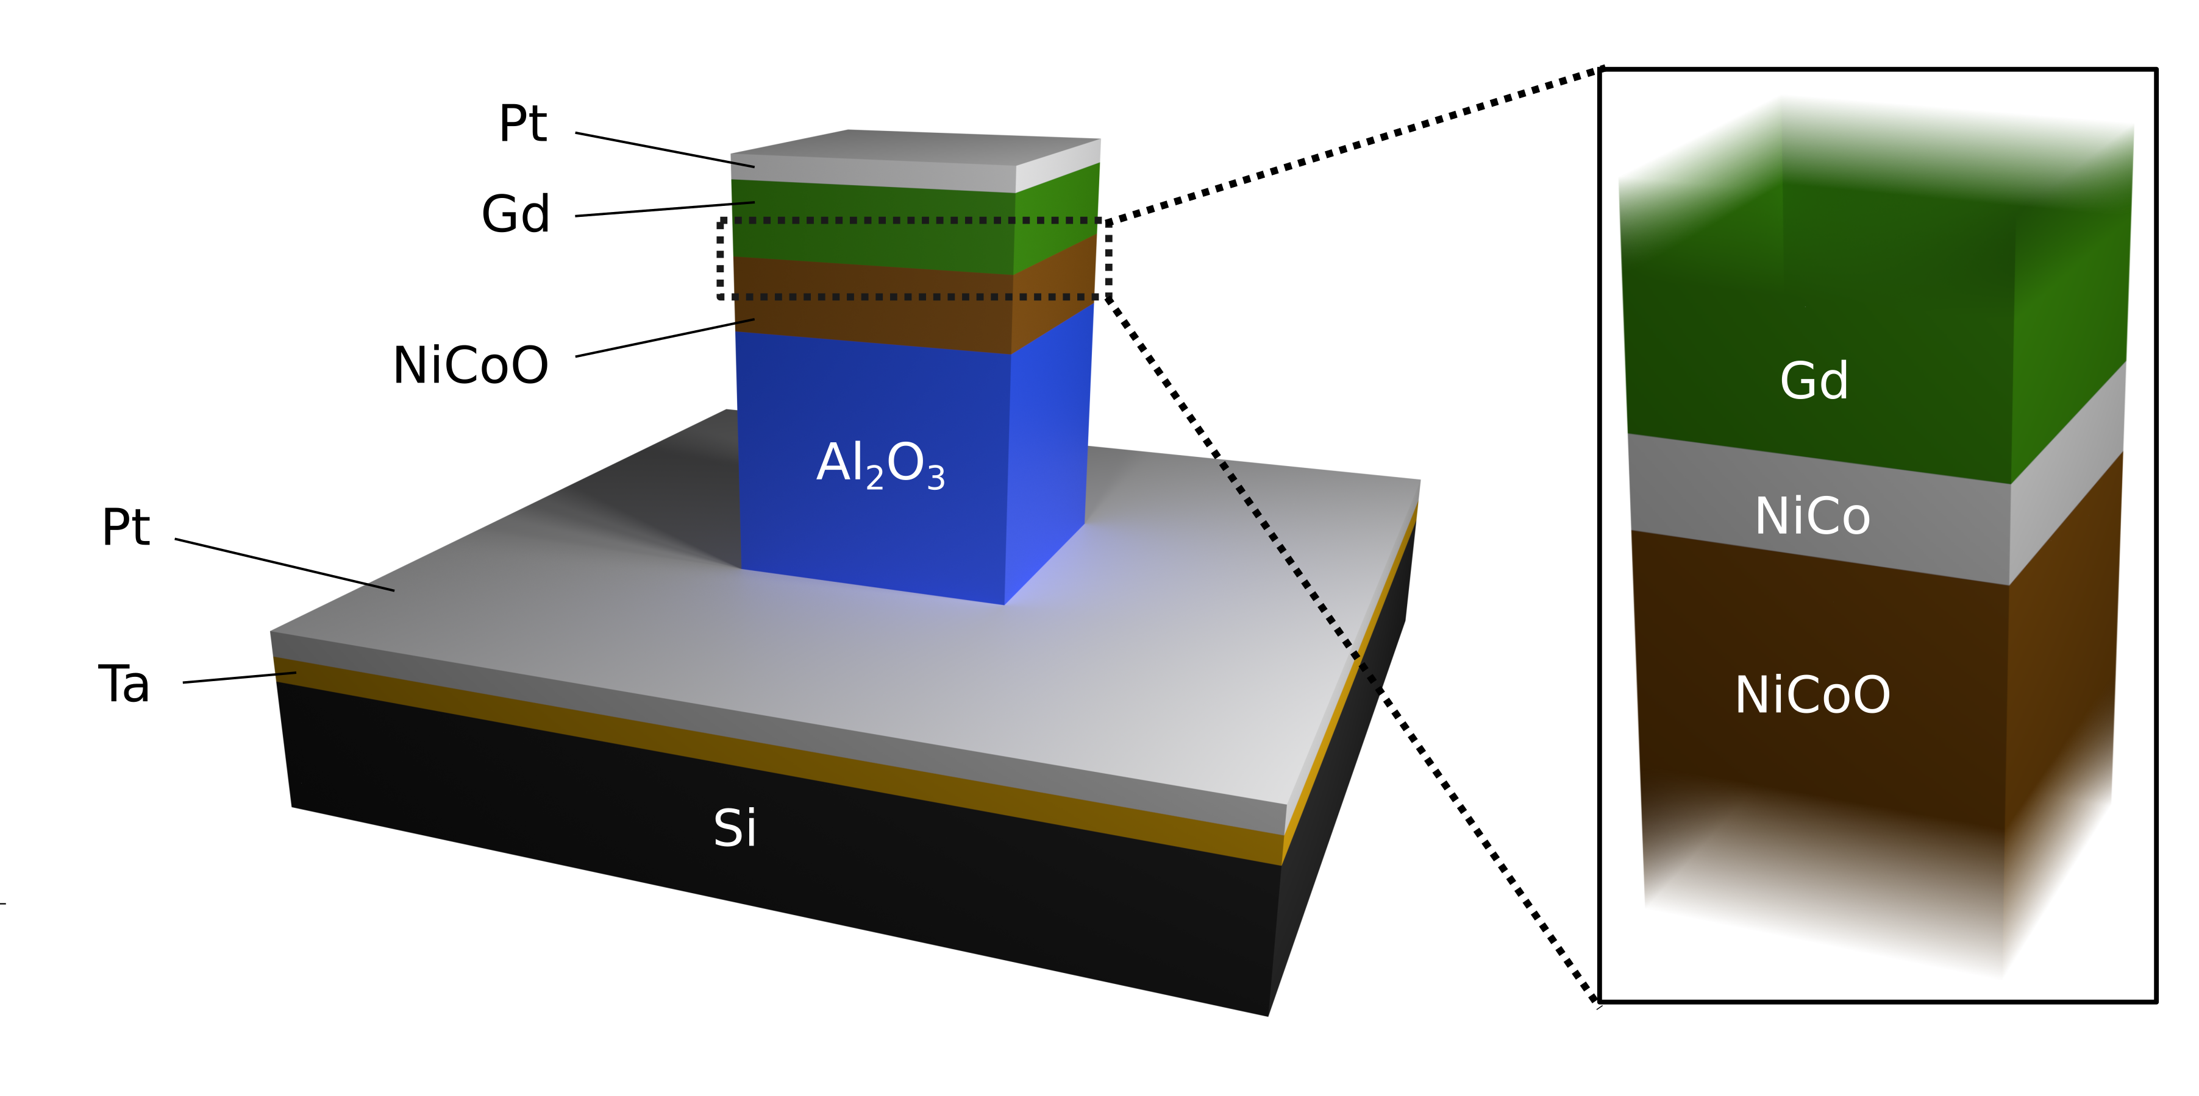

**Fig. 1**

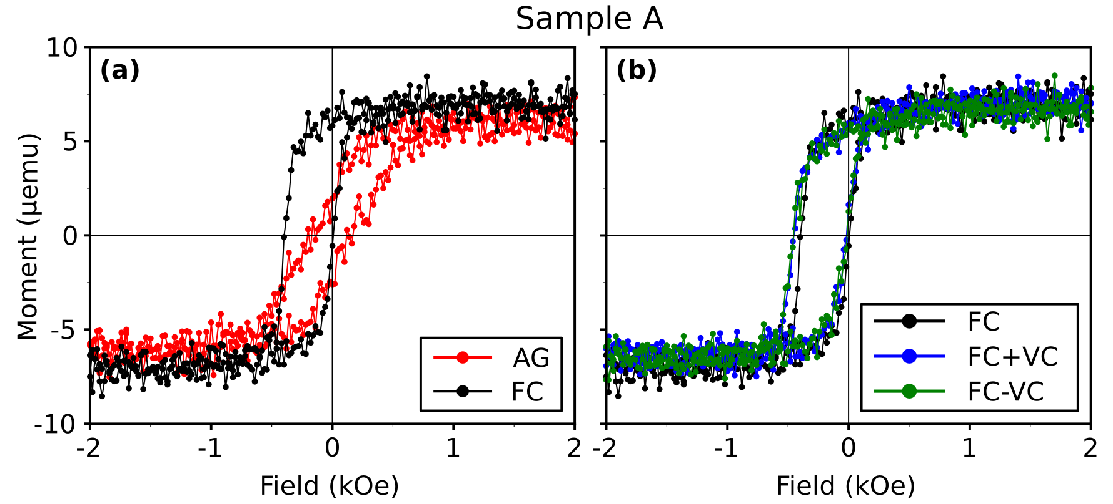

**Fig. 2**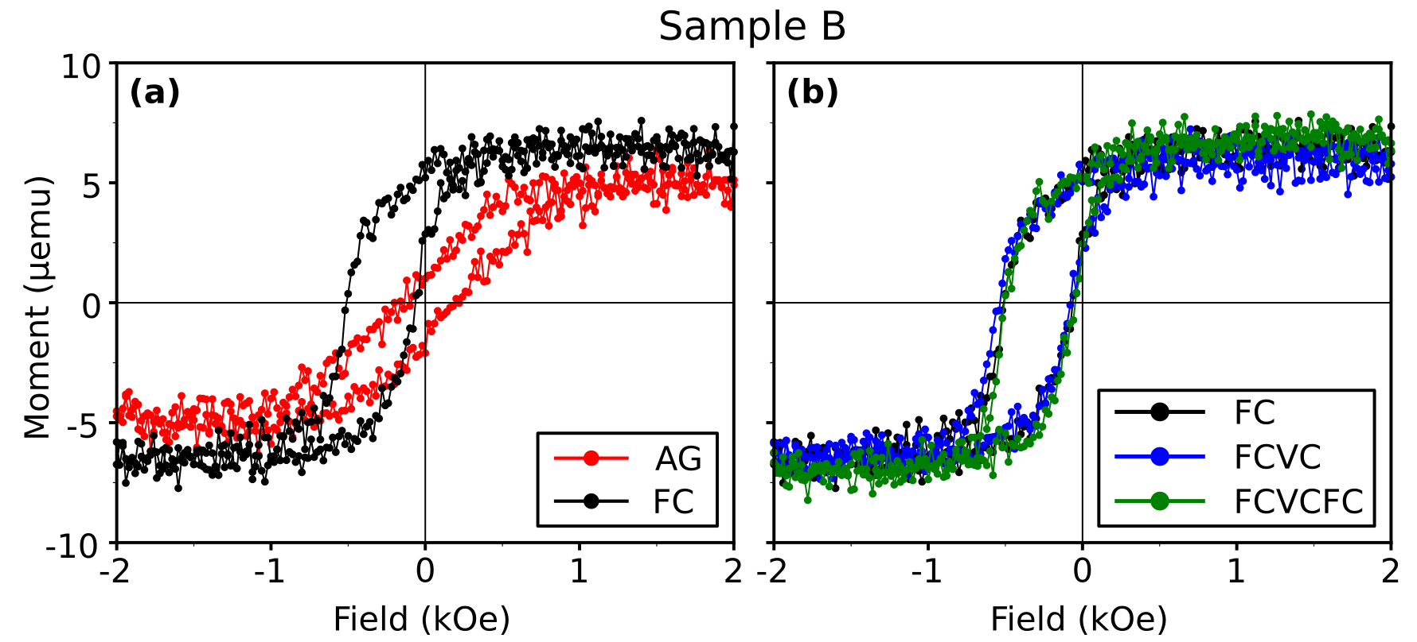

**Fig. 3**

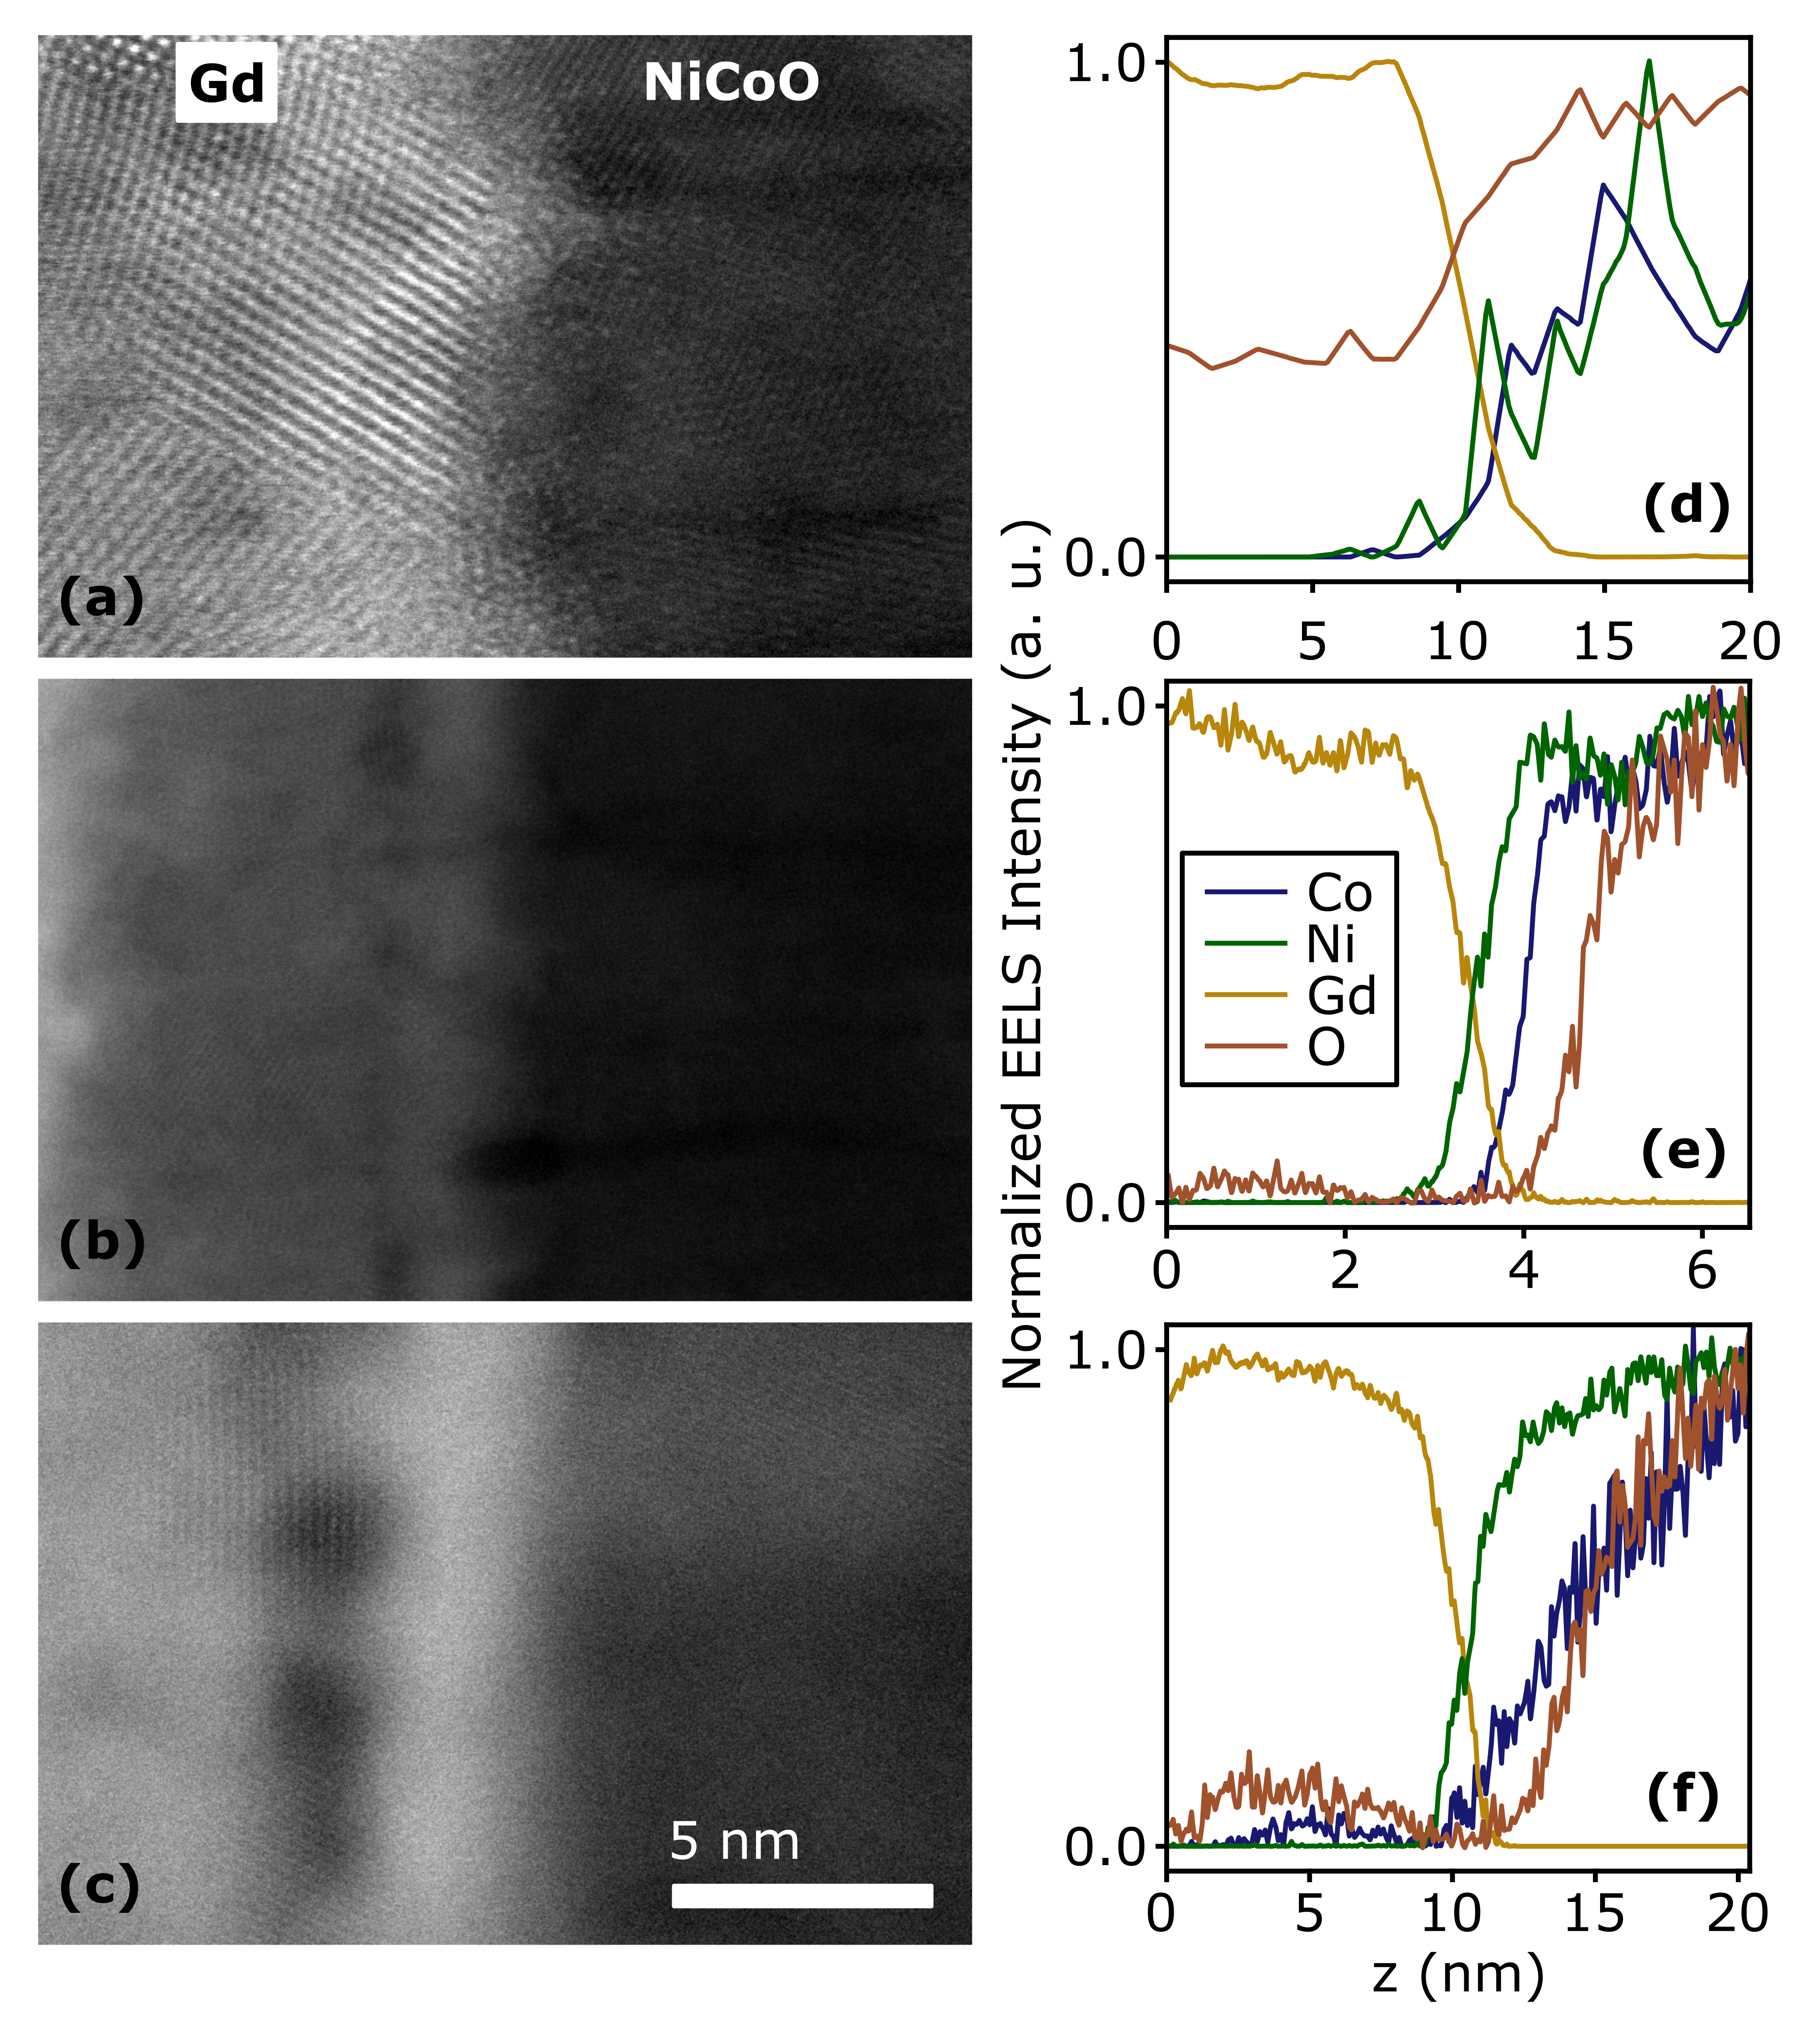

**Figure 4**

**References**

1. Bauer, U. *et al.* Magneto-ionic control of interfacial magnetism. *Nat. Mater.* **14,** 174–181 (2015).

2. Bi, C. *et al.* Reversible control of Co magnetism by voltage-induced oxidation. *Phys. Rev. Lett.* **113,** 267202 (2014).

3. Bauer, U., Emori, S. & Beach, G. S. D. Voltage-controlled domain wall traps in ferromagnetic nanowires. *Nat. Nanotechnol.* **8,** 411–416 (2013).

4. Gilbert, D. A. *et al.* Structural and magnetic depth profiles of magneto-ionic heterostructures beyond the interface limit. *Nat. Commun.* **7,** 12264 (2016).

5. Grutter, A. J. *et al.* Reversible control of magnetism in La0.67Sr0.33MnO3 through chemically-induced oxygen migration. *Appl. Phys. Lett.* **108,** 082405 (2016).

6. Gilbert, D. A. *et al.* Controllable positive exchange bias via redox-driven oxygen migration. *Nat. Commun.* **7,** 11050 (2016).

7. Gilbert, D. A. *et al.* Ionic tuning of cobaltites at the nanoscale. *Phys. Rev. Mater.* **2,** 104402 (2018).

8. Nogués, J. & Schuller, I. K. Exchange bias. *J. Magn. Magn. Mater.* **192,** 203–232 (1999).

9. Kiwi, M. Exchange bias theory. *J. Magn. Magn. Mater.* **234,** 584–595 (2001).

10. Ohldag, H. *et al.* Correlation between Exchange Bias and Pinned Interfacial Spins. *Phys. Rev. Lett.* **91,** 2–5 (2003).

11. Berkowitz, A. E. & Takano, K. Exchange anisotropy — a review. *J. Magn. Magn. Mater.* **200,** 552–570 (1999).

12. Kittel, C. *Introduction to Solid State Physics*. (John Wiley & Sons, Inc, 2005).

13. Ambrose, T., Liu, K. & Chien, C. L. Doubly exchange-biased NiCoO/NiFe/Cu/NiFe/NiCoO spin valves. *J. Appl. Phys.* **85,** 6124–6126 (1999).

14. Yang, D. Z. *et al.* Positive exchange biasing in GdFe/NiCoO bilayers with antiferromagnetic coupling. *Phys. Rev. B - Condens. Matter Mater. Phys.* **71,** 144417 (2005).

15. Balluffi, R. W., Allen, S. M. & Carter, W. C. *Kinetics of Materials*. (A. John Wiley & Sons, 2005).

16. Hotovy, I., Liday, J., Spiess, L., Sitter, H. & Vogrincic, P. Study of Annealed NiO Thin Films Sputtered on Unheated Substrate. *Japanese J. Appl. Physics, Part 2 Lett.* **42,** (2003).

17. Kim, Y. M. *et al.* Probing oxygen vacancy concentration and homogeneity in solid-oxide fuel-cell cathode materials on the subunit-cell level. *Nat. Mater.* **11,** 888–894 (2012).

18. Colinet, C., Pasturel, A. & Buschow, K. H. J. Study of the Enthalpies of Formation in the Gd-Ni System. *Metall. Trans. A* **17A,** (1986).

19. Colinet, C., Pasturel, A. & Buschow, K. H. J. Study of the enthalpies of formation in the Gd-(Fe, Co, Pd, Pt) systems. *Metall. Trans. A* **18,** 903–907 (1987).

20. Dean, J. A. *Lange’s Handbook of Chemistry*. (McGraw-Hill, 1999).

21. Malozemoff, A. P. Random-field model of exchange anisotropy at rough ferromagnetic- antiferromagnetic interfaces. *Phys. Rev. B* **35,** 3679–3682 (1987).